**Q5. Japanese Cities' Attributes**

Query all attributes of every Japanese city in the CITY table. The COUNTRYCODE for Japan is JPN.

The CITY table is described as follows:

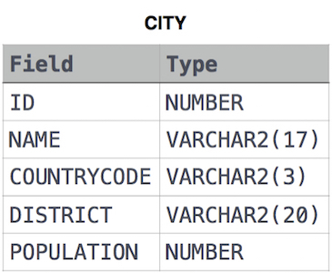

Ans.

SELECT *

FROM CITY

WHERE COUNTRYCODE = 'JPN'